April 25 – Bug Docu/Not working functionalities

Failed to Create Question – Dean
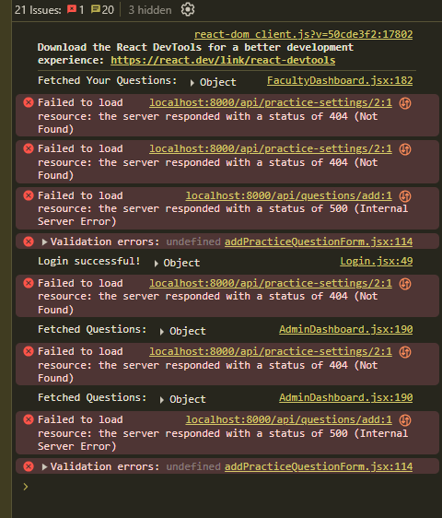

Faculty Can get and assign subject but Can’t add question
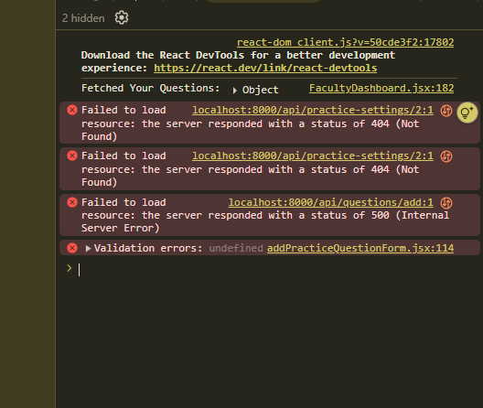

April 26 – Bug Docu/Not working functionalities

Program Chair can’t Accept Dean’s Question
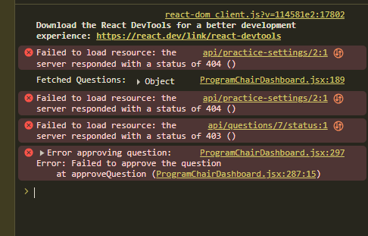

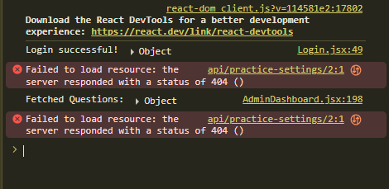
Image Can’t be added to the question

Cannot view image on choices after adding
